**Mr. Visca’s: Calculus (Chpt 5.3)**

**Chpt 5 – Day 3: Definite Integrals & AntiDerivatives**

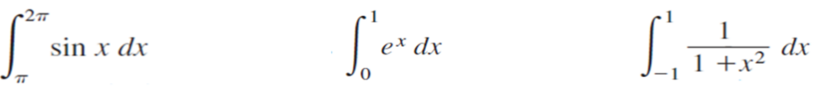A couple more practice...

**Properties/Rules for Definite Integrals**

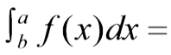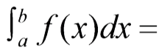

1. Order of Integration

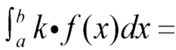2. Zero

3. Constant Multiple

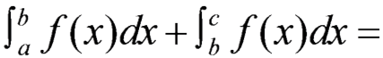4. Sum & Difference

5. Additivity

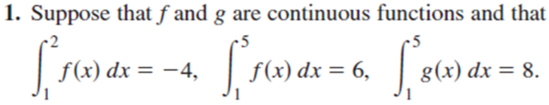

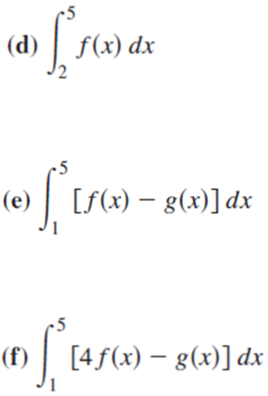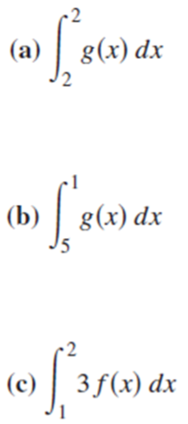

The average value of a function is the value that would give the same area if the function was a constant

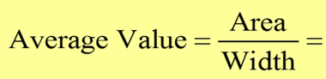

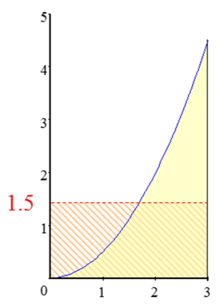

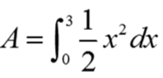

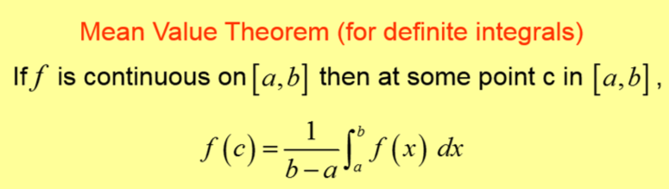

This leads way to...



**HOMEWORK:**

Page 290-291: 2, 4, 6, 20-36 even